
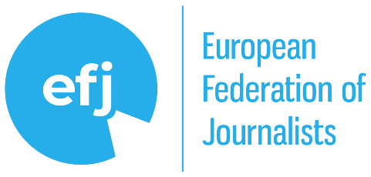


Brussels, 5 April 2025
Dear Reader,
Human creativity and culture are the enablers of innovation, including Artificial Intelligence. Innovation, however, cannot come at the expense of human creativity and culture. When Al systems exploit online creative and cultural content -including press content- to fuel their own services, they unduly profit from human work.
AI poses a double societal challenge: protecting both citizens’ fundamental rights and the link between human-made content and the machines that use it. When Generative AI uses journalistic and editorial materials notably to produce, without permission or remuneration, parasitic press-like content at minimal cost and without editorial oversight, everyone loses.
We are also witnessing the worrying rise of AI-fuelled online disinformation, via the generation of realistic yet misleading AI content that spreads faster than it can be verified.
Current national and EU laws lack solid guardrails ensuring that creators and citizens alike benefit from AI developments with due regard to transparency, accountability, and due remuneration of the rightsholders – all crucial.
We strongly believe that everyone should benefit from AI, including citizens and content providers. After all, professional cultural and creative content is the indispensable raw material powering the AI revolution, without which quality AI cannot exist.
AI can be a force for good if specific risks are countered. We urge the new European Commission to act now to support the prosperity and sustainability of European media, culture, information, and the democratic health of our societies.

About the authors: The European Federation of Journalists (EFJ), European Magazine Media Association (EMMA), European Newspaper Publishers’ Association (ENPA) and News Media Europe (NME) collectively represent tens of thousands of journalists and newspaper and magazine publications across Europe. As the leading voices of the industry, they advocate inter alia for press freedom, media sustainability, and a diverse, independent journalism landscape, working to ensure fair access to digital platforms, promote transparency in algorithmic content distribution, and push for balanced regulatory frameworks that support professional press and journalism in the digital age.

